COS10004 – Computer System
Lab 10 – Flashy Function
Name: Tran Quang Huy
Studentid: 106212636
10.1
(a) First write the delay function. This function should take a single input, the number of seconds to delay for and be called from the main program every time there is a pause required.
delay:
PUSH {R3, R4, R5}
LDR R4, .Time
MOV R3, R0 #Stores the delays
(b) Then write the drawpixel function. This function should take two inputs: the colour of the pixel to draw, and the time delay between on and off. This function should also call the delay function to insert the pauses between on and off.
drawpixel:
PUSH {LR, R1, R2}
MOV R2, R0
MOV R1, R2
BL delay
MOV R2, #0
MOV R0, R2
BL delay
POP {LR, R1, R2}
RET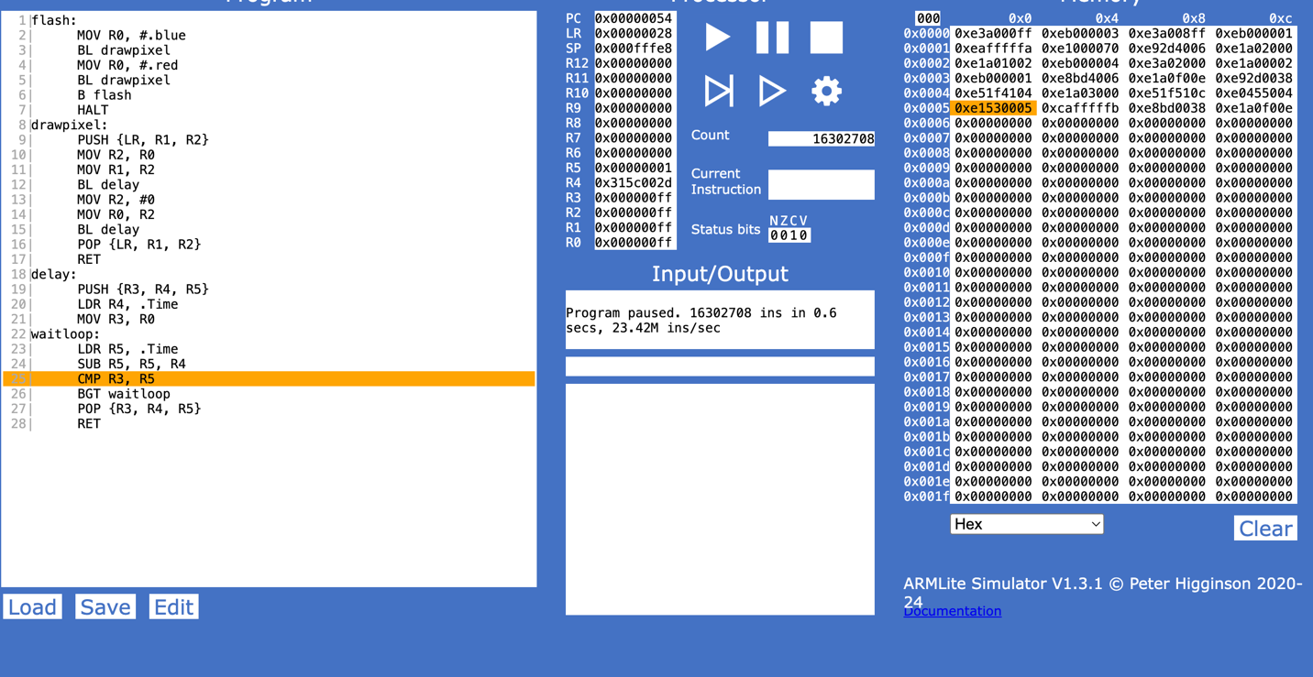
(c) when you implemented drawpixel, what did you have to do with LR to make it work? Why?
When implementing drawpixel, I had to push LR onto the stack at the start and pop it back before returning. This is because when flash calls drawpixel using BL, the return address back to flash gets stored in LR. The problem is that inside drawpixel, I also call BL delay, which overwrites LR with a new return address. This means the original return address to flash would be lost. So by pushing LR at the beginning with PUSH {LR, R1, R2}, I can save it before it gets overwritten. Then after the delay calls are done, I restore it with POP {LR, R1, R2} so that RET can correctly jump back to flash.

10.2
Modify your program above so that your program flashes the LED rapidly (i.e., 1 second between on and off) three times and then pauses for 2 seconds before repeating the rapid pattern. You should make use of your drawpixel and delay functions to do this.
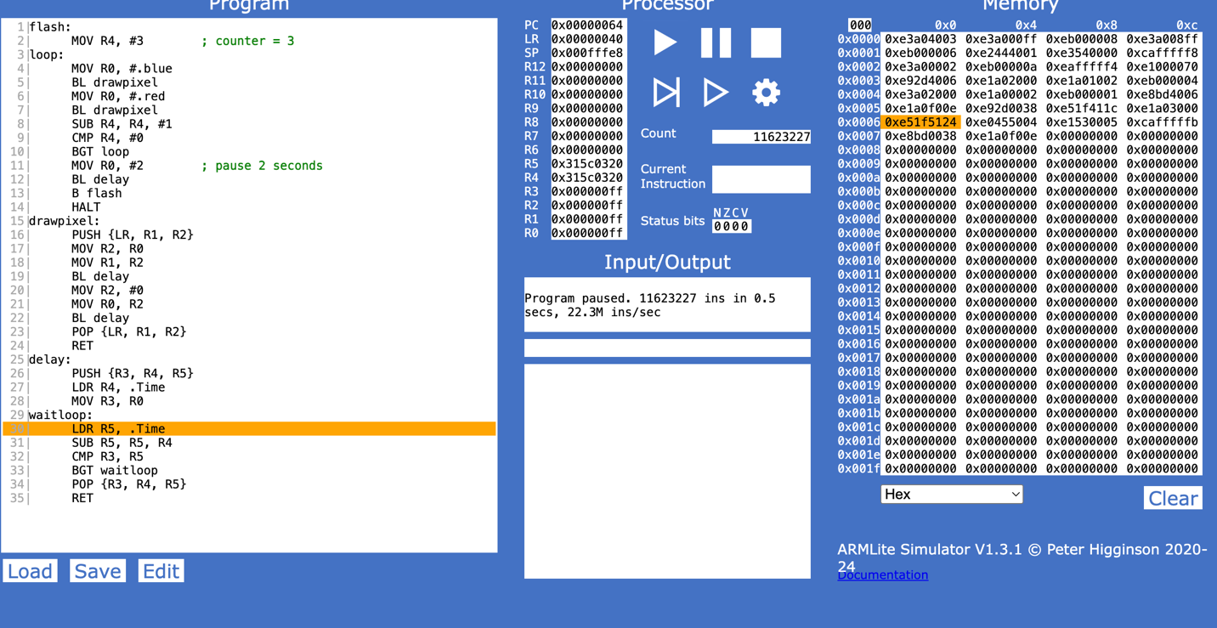
10.3
Modify your program from 10.2 by writing a function called flashpattern: that accepts two inputs:
- the number of "rapid" 1 second flashes before the pause
- the pause time (in seconds) between each set of rapid flashes
1|flash:
2| MOV R0, #3 ; number of rapid flashes
3| MOV R1, #2 ; pause time in seconds
4| BL flashpattern
5| B flash
6| HALT
7|flashpattern:
8| PUSH {LR, R2, R3, R4}
9| MOV R3, R0 ; R3 = number of flashes
10| MOV R4, R1 ; R4 = pause time
11|flashloop:
12| MOV R0, #.blue
13| BL drawpixel
14| MOV R0, #.red
15| BL drawpixel
16| SUB R3, R3, #1
17| CMP R3, #0
18| BGT flashloop
19| MOV R0, R4 ; load pause time
20| BL delay
21| POP {LR, R2, R3, R4}
22| RET
23|drawpixel:
24| PUSH {LR, R1, R2}
25| MOV R2, R0
26| MOV R1, R2
27| BL delay
28| MOV R2, #0
29| MOV R0, R2
30| BL delay
31| POP {LR, R1, R2}
32| RET
33|delay:
34| PUSH {R3, R4, R5}
35| LDR R4, .Time
36| MOV R3, R0
37|waitloop:
38| LDR R5, .Time
39| SUB R5, R5, R4
40| CMP R3, R5
41| BGT waitloop
42| POP {R3, R4, R5}
43| RET

